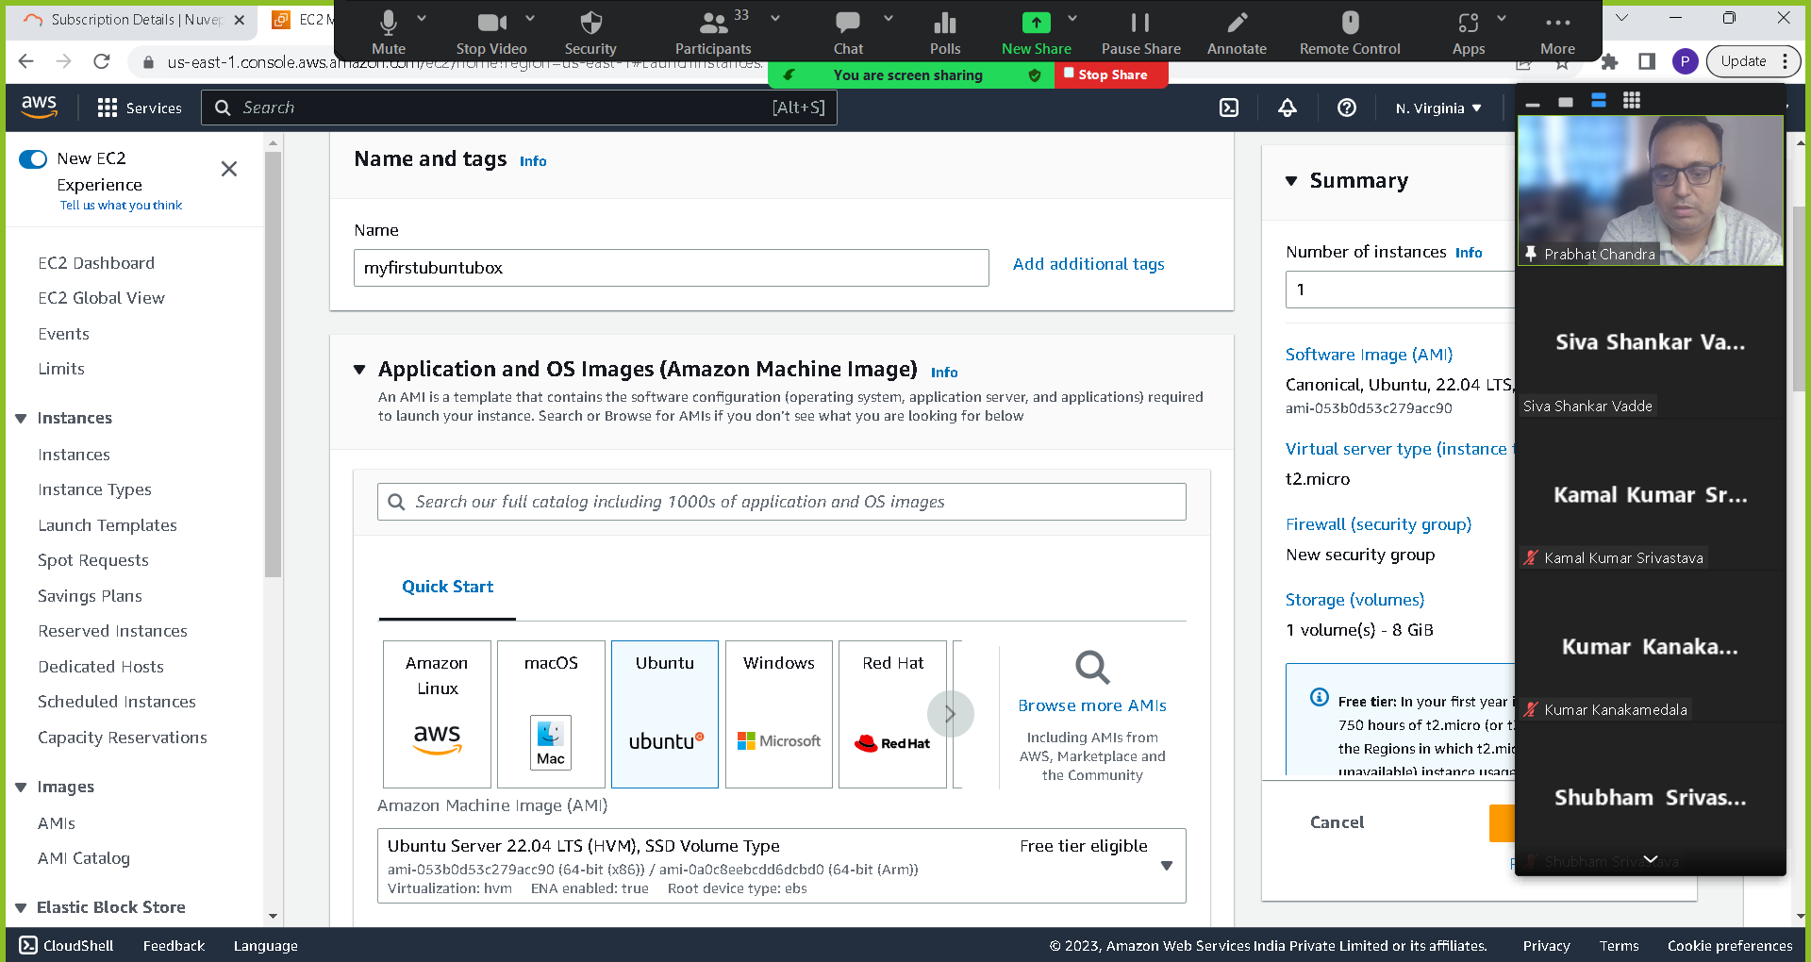

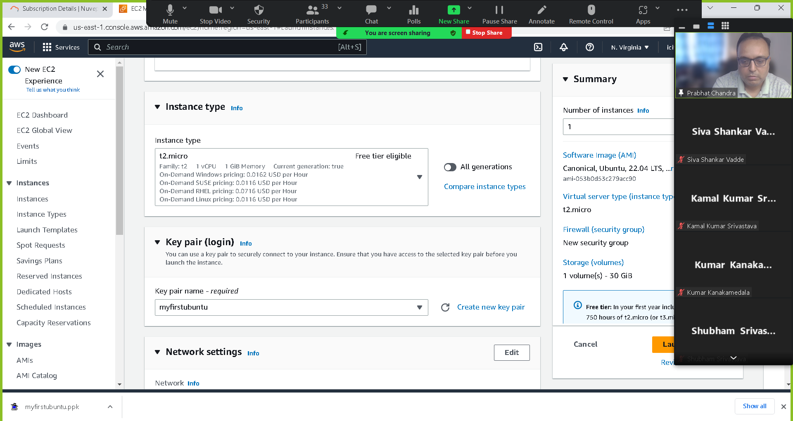

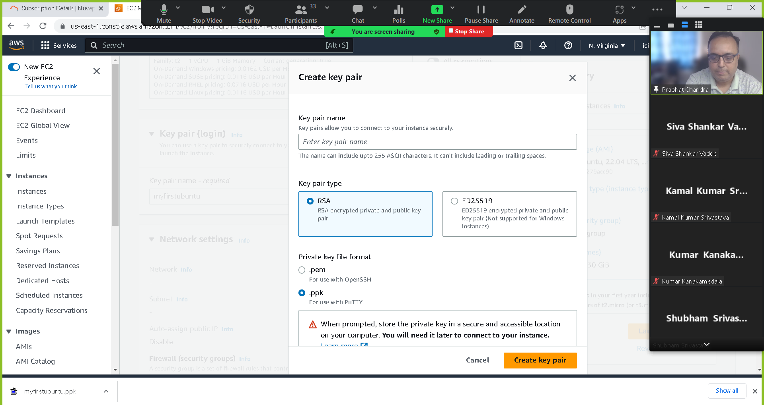

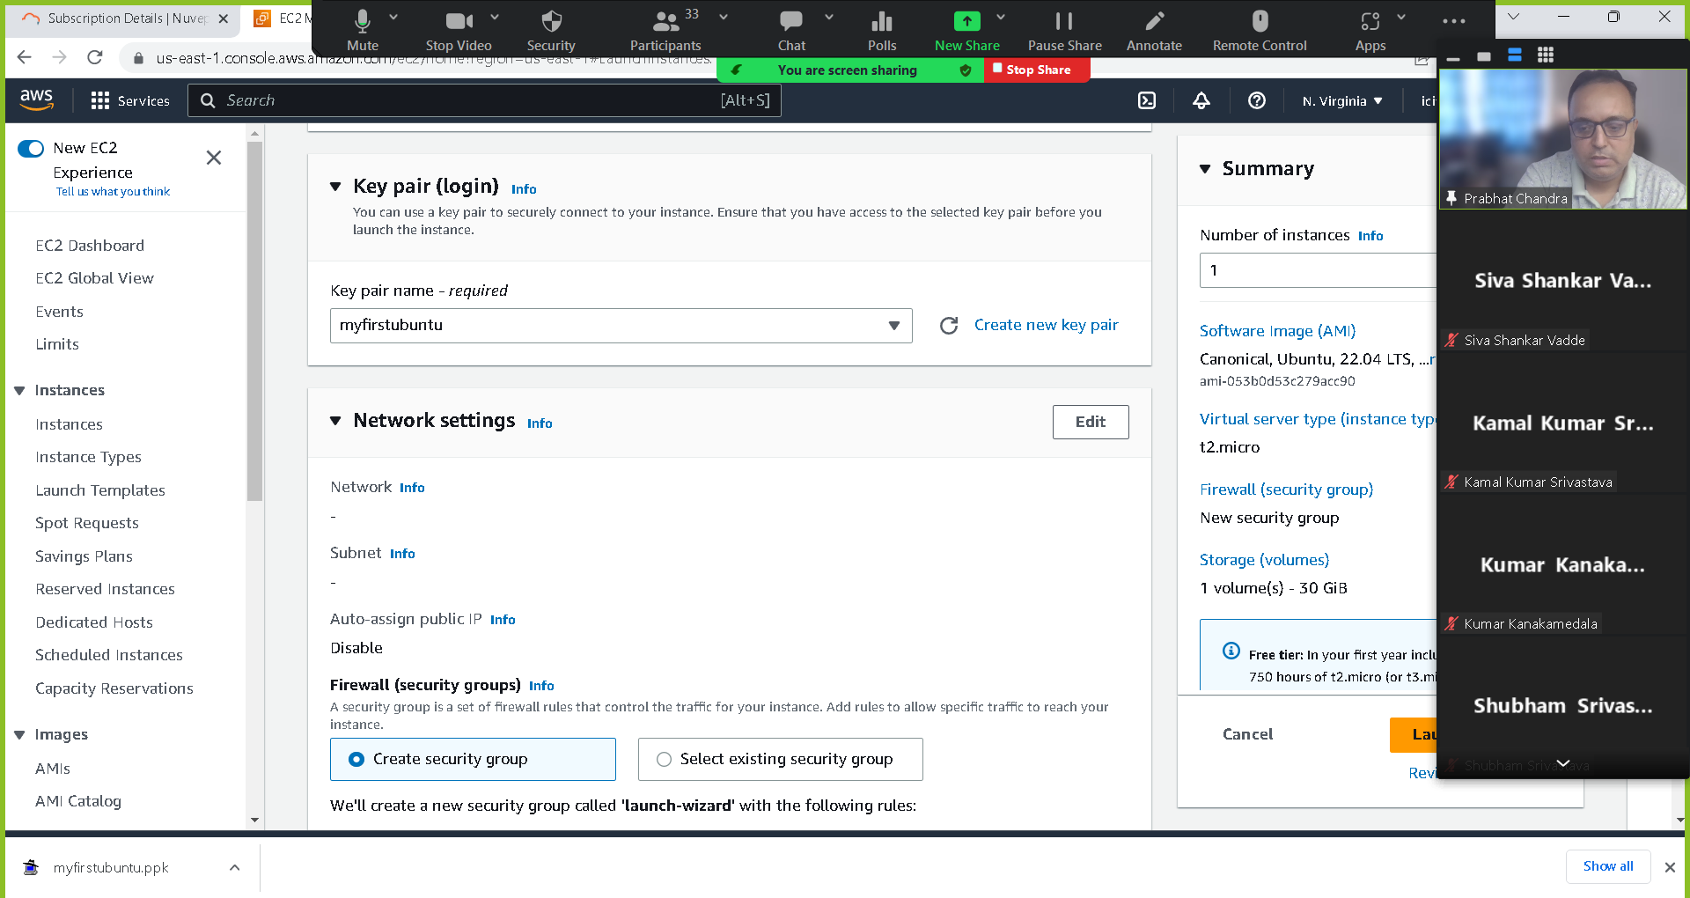

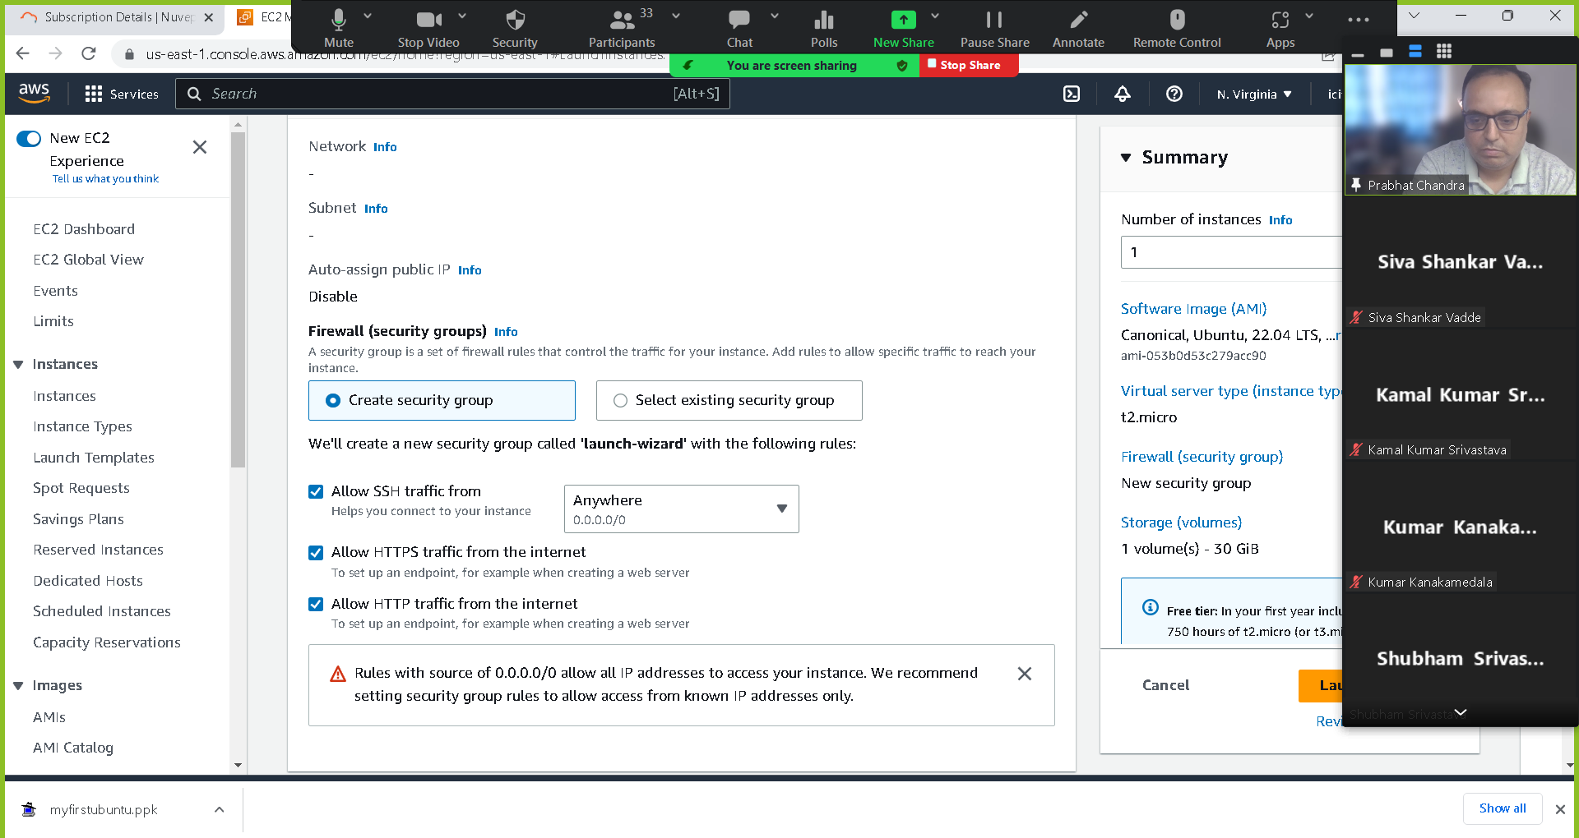

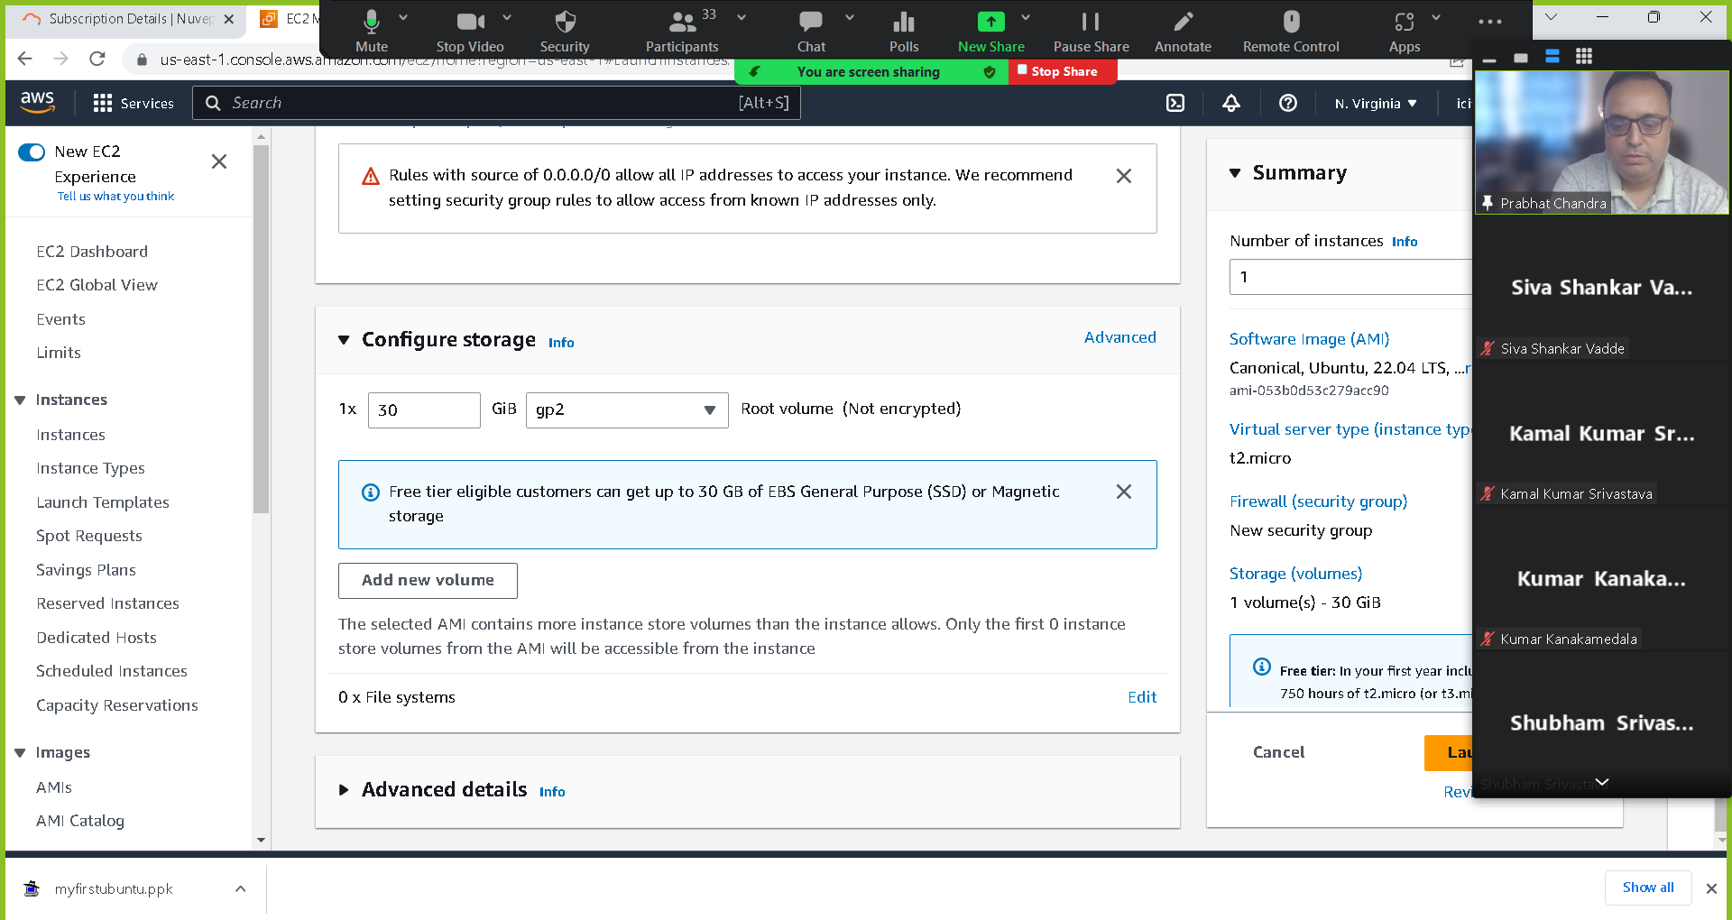

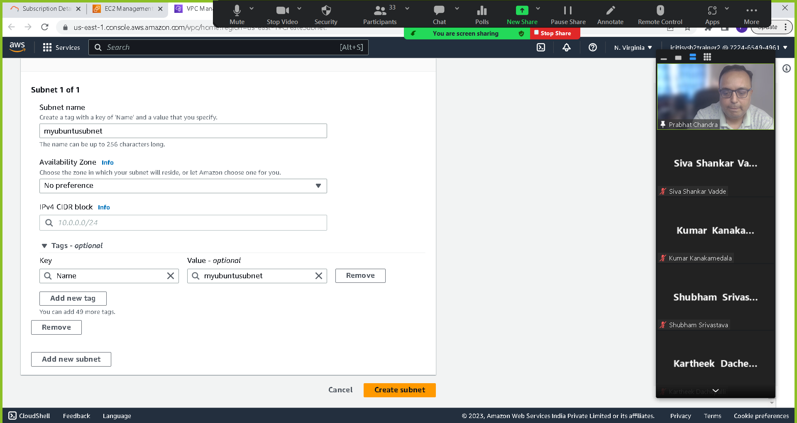

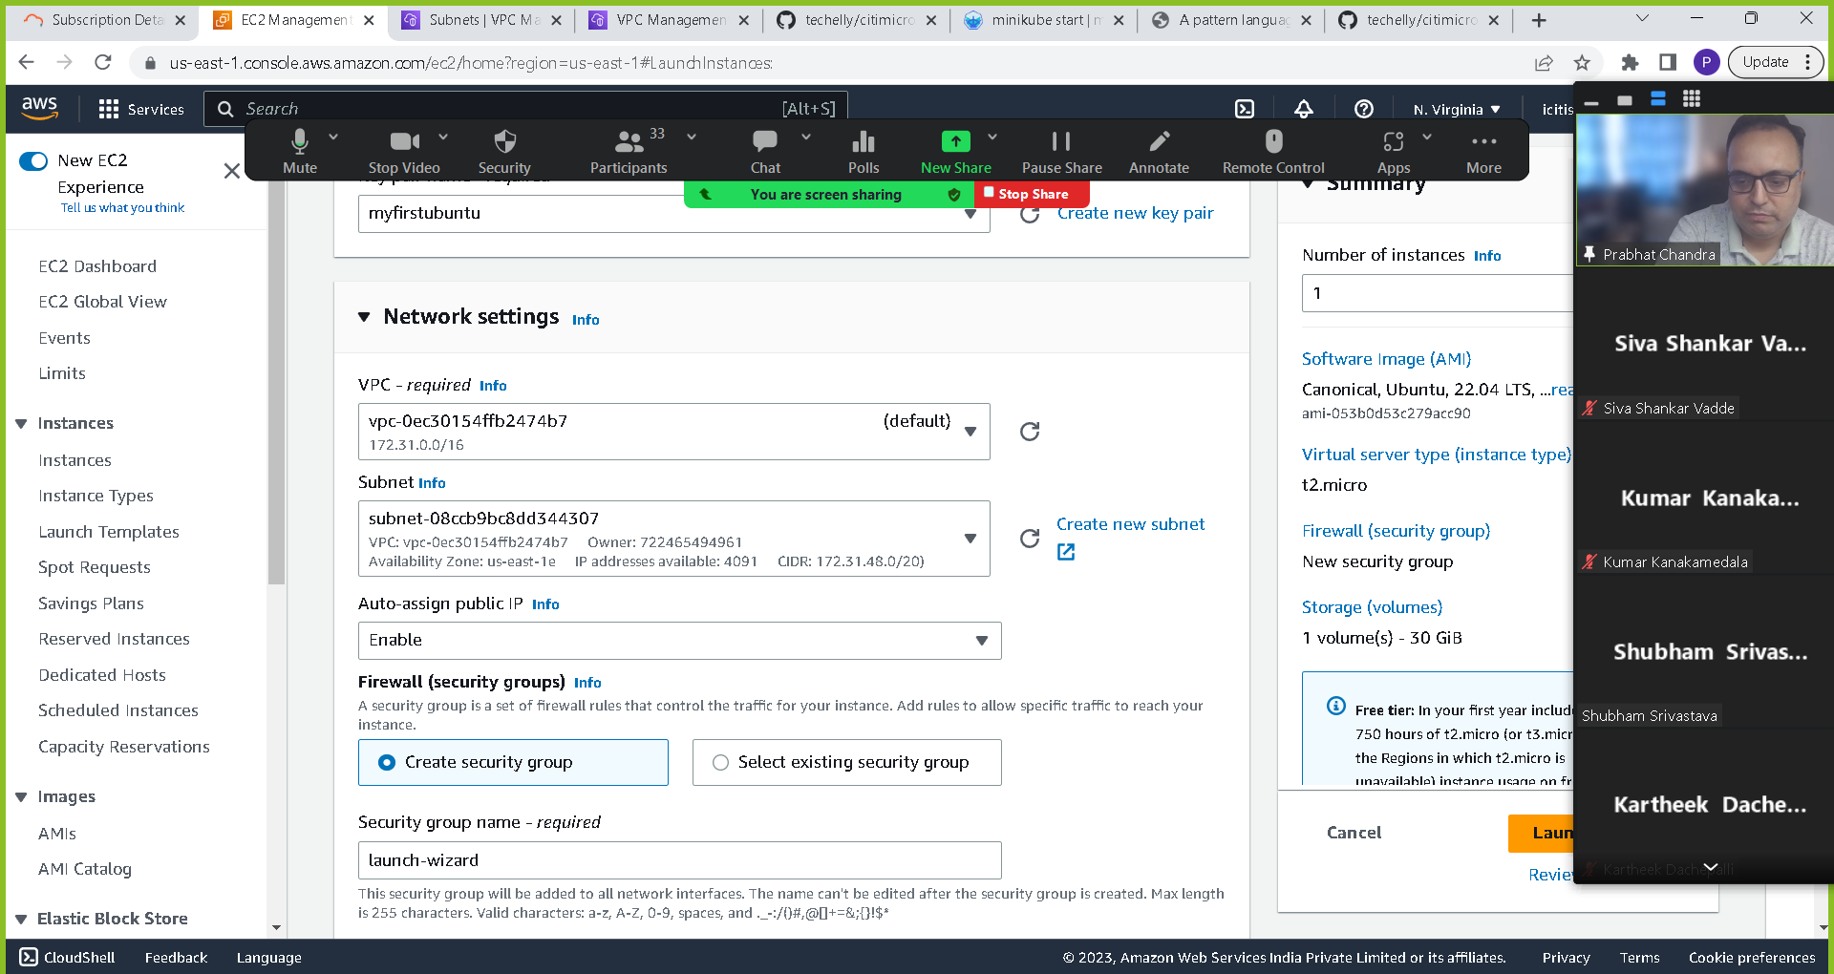

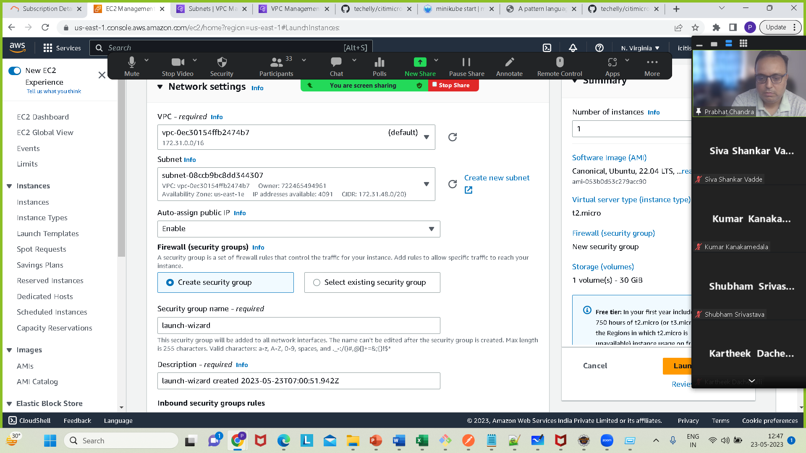

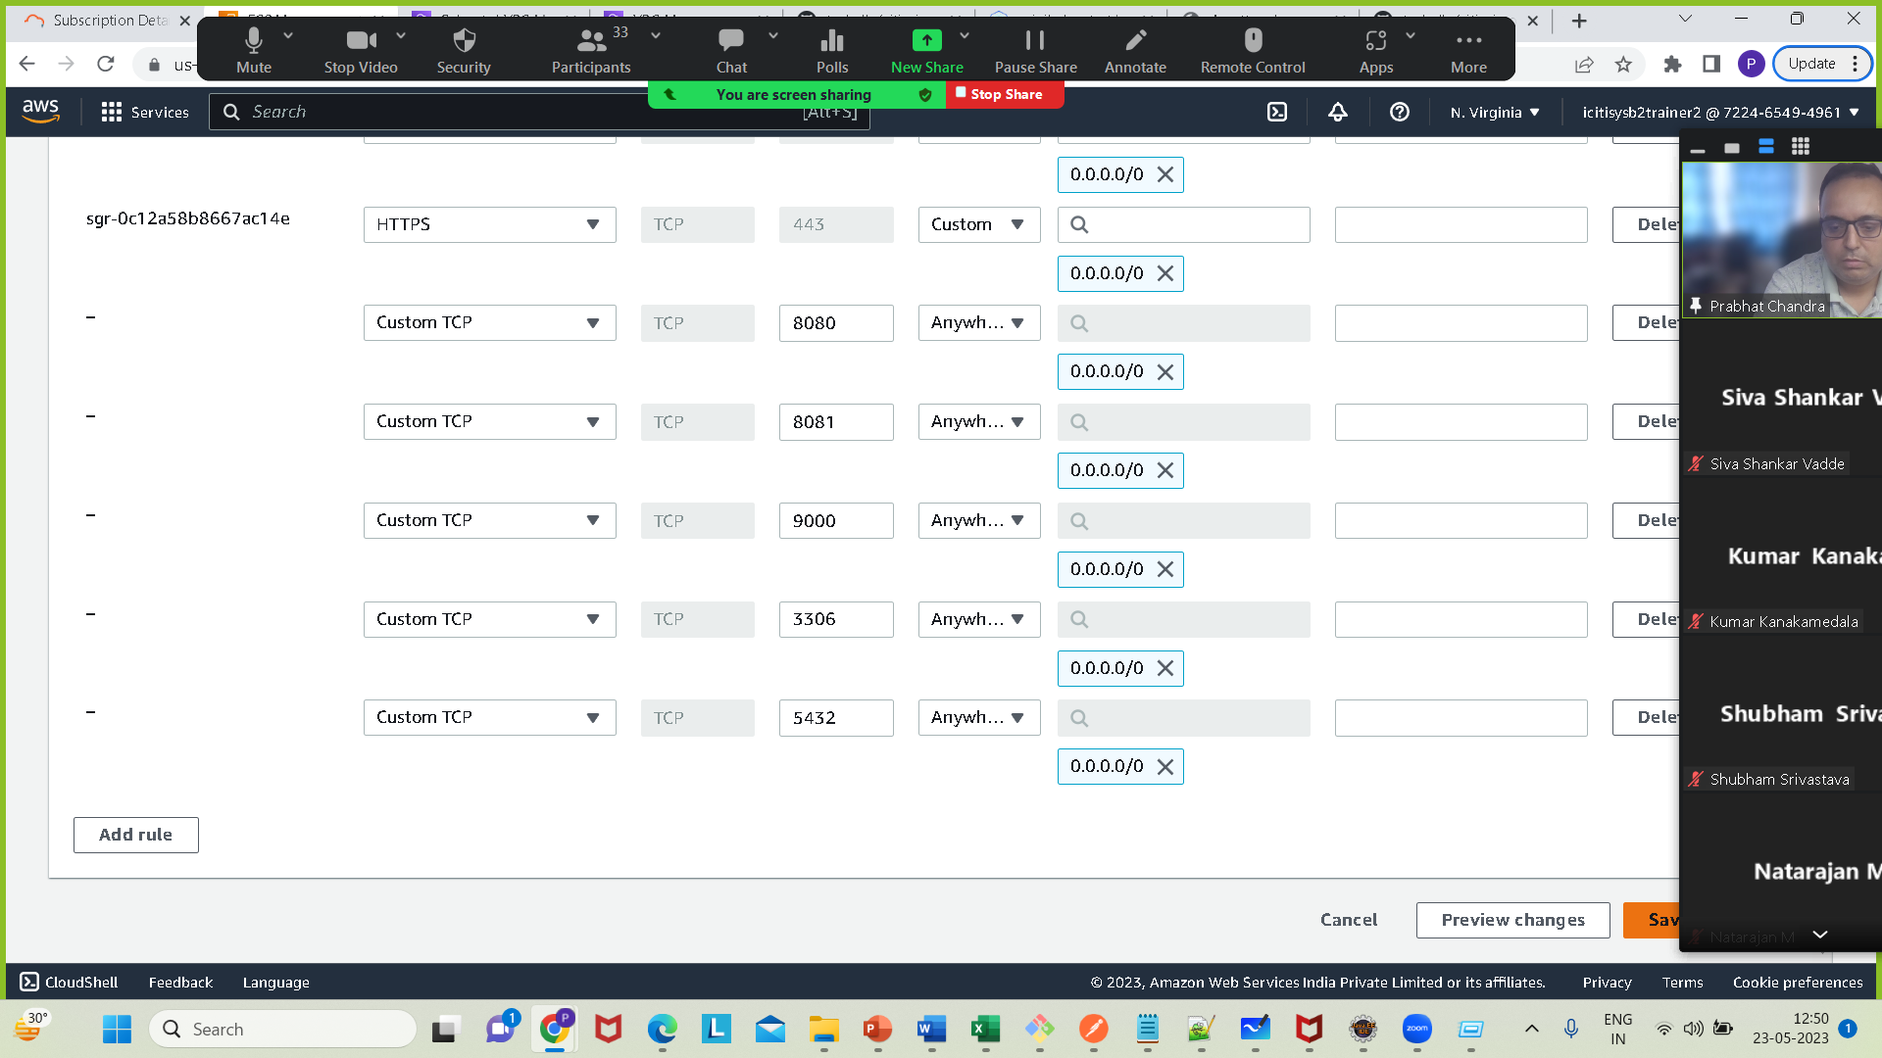

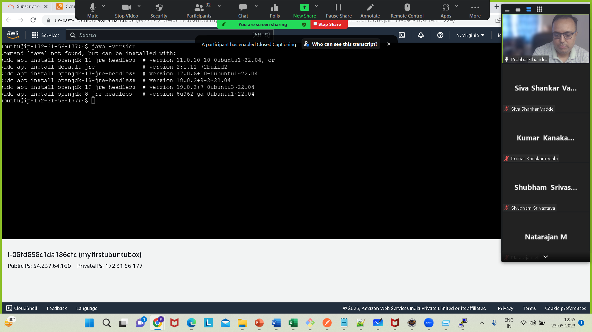

sudo apt update

sudo apt install openjdk-17-jdk

java -version

export JAVA_HOME=/usr/lib/jvm/java-17-openjdk-amd64

or

sudo nano /etc/environment

paste JAVA_HOME in path variable as below

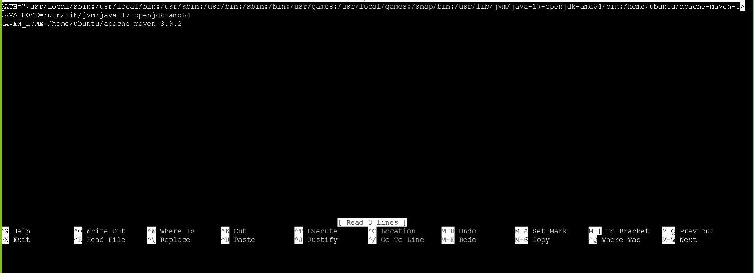

For Docker installation see another file

Now install git

sudo apt install git

git –version

Then configure the git

git config --global user.name "techelly"

git config --global user.email [prabhat@learnwithtechelly.com](mailto:prabhat@learnwithtechelly.com)

Install maven

Go to https://maven.apache.org/download.cgi

Copy the link for the binary tar.gz archive

Then

wget <https://dlcdn.apache.org/maven/maven-3/3.9.2/binaries/apache-maven-3.9.2-bin.tar.gz>

tar -xvf apache-maven-3.9.2-bin.tar.gz

Set Path of Maven

export M2_HOME=/home/ubuntu/apache-maven-3.9.2

export PATH="$M2_HOME/bin:$PATH"

compile source code using mvn command as below

cd helloworldexample

mvn clean install

Run the application using

mvn spring-boot:run

Open a new tab

http://<url>:8080/api/v1/greet/greeting

Then create image of our application :

sudo docker build --tag helloworldexample .

Go to directory where you have Dockerfile

sudo docker build –tag helloworldexample .

sudo docker images

sudo docker run --pubish 8080:8080 helloworldexample